

To: City Executive Board
Council

Date: 12 June 2013

Report of: Regeneration and Major Projects Manager

Title of Report: APPOINTMENT OF MAIN CONTRACTOR FOR AFFORDABLE HOMES PROGRAMME 2015

Summary and Recommendations

Purpose of report: To obtain approval to proceed to let the main construction contract and subsequent call off contracts for the Affordable Homes Programme.

Key decision? Yes

Executive lead member: Councillor Scott Seamons

Report approved by: David Edwards

Finance: Nigel Kennedy

Legal: Lindsay Cane

Policy Framework: Meeting Housing Needs.

Recommendation(s): That the City Executive Board;

- Authorise the Executive Director for Regeneration and Housing to select the final sites for the 112-114 new homes to be built on;

- Agree the Cost Plan in Exempt Information Annex 3;

- Authorise the Executive Director for Regeneration and Housing to let the main build contract and any subsequent “call off” contracts where total build costs (including contingencies) are equal to the Cost Plan; and

- Authorise the Executive Director for Regeneration and Housing to agree any cost overruns that can be contained within the overall budget envelope of the Affordable Homes Programme to be certified as such by the Project Manager.

Appendices

- Project Execution Plan (PEP) & Programme
- Risk Register

Exempt Information Annex

- Cost Plan
- Tender and Evaluation Summary
- ITT
- PEP (Exempt Information)

Executive Summary

- Following approval to proceed with the Affordable Homes Programme 2012-15 (AHP), the Council have appointed professional teams to prepare up to 16 sites for development of 112 new Council homes by March 2015.

- The tender process will involve the appointment of a main contractor (s) with agreed “call off arrangements” for sites to be brought into this contract as they receive planning permission and are selected by the Project Board and the Executive Director for inclusion in the programme.

- An agreed “Cost Plan” has been produced by the Council’s consultants, which provides a cost “ceiling” for delivery of the 112 new homes.

- Because of timing constraints with the overall programme, it is proposed that delegated authority is provided in advance to the Executive Director of Regeneration and Housing to authorise the appointment of main contractor (s) and all subsequent contractors, within this agreed overall cost envelope. The Executive Director will only be able to authorise projected cost overruns on individual sites, where these overruns can be contained within the overall programme budget envelope, to be certified as such by the Project Manager.

Background

- On 15th February 2012, through Single Member Decision, the Council agreed to:

- Approve the proposed Affordable Homes Programme 2012-15 (AHP) as detailed herein;

- Authorise the Head of Corporate Assets to negotiate and complete the New Framework Delivery Agreement (FDA) with the Homes and Communities Agency (HCA);

- Authorise the Head of Housing and Communities to undertake the decant process of Bradlands under Phase 1; and

- Authorise the Head of Corporate Assets in consultation with the Executive Member of Housing Needs to approve the final selection of sites for Phase 2 and Phase 3.

- The Council have subsequently executed a Framework Delivery Agreement (FDA) with the HCA, which, inter alia, commits the Council to deliver 112 new homes by March 2015 in return for the agreed grant funding from the HCA. The grant is payable in part (50%) at the start on site for each dwelling and concluding with the remainder (50%) at “practical completion”. The funding is further conditional on creating at least 44 Affordable Rented units within the programme, with the remainder being Affordable Social Rented.

Affordable Rent homes can be made available to tenants up to a maximum of 80% of market rent and allocated in the same way as social housing is at present. It is expected that Affordable Rent accommodation will be used flexibly as an alternative to private rented housing and not to replace Social Rent homes.

- A professional team lead by EC Harris as Project Managers has subsequently been appointed under an existing public sector framework, to mobilise a team to take forward up to 16 sites in total for potential inclusion in the AHP programme to deliver the 112 new homes by March 2015.

- A dedicated AHP Project Board has been established (Chaired by Service Manager for Regeneration and Major Projects), with agreed governance arrangements, and a Project Execution Plan in place. The Project Execution Plan (PEP) can be viewed in Appendix 1.

- Site due diligence, design and planning consultation has been undertaken on 16 sites, with the potential to produce up to 157 new homes. Planning applications have a forecast submission between May and June 2013 (with the exception of Bradlands which has a detailed permission in place).

These sites include:

Site | Dwellings numbers
Bradlands | 49
Warren Crescent | 10
Eastern House | 9
Alice Smith House | 11
East Minchery Farm | 42
Bury Knowle Depot | 10
Balfour Road | 3
Sandy Lane | 3
Tompson Terrace | 3
Tucker Road | 2
David Walter Close (East) | 2
David Walter Close (West)  High Cross Way A  High Cross Way B | 2  3  2
Leiden Road | 3
Cardinal Close | 3
TOTAL | 157

- At this time, the project will only take forward sites to deliver 112-114 new homes, based on the budget envelope agreed within the HRA Business Plan, and therefore the Project Board have approved the following delivery options to achieve the unit numbers and split of tenures between Affordable Social Rented and Affordable Rented units:

Option 1
Site | Social Rent | Affordable Rent
Bradlands | 49 | 0
Warren Crescent | 0 | 10
Bury Knowle | 0 | 10
Minchery Farm | 21 | 21
Cardinal Close | 0 | 3
Total | 70 | 44
Total 114

Option 2
Site | Social Rent | Affordable Rent
Bradlands | 49 | 0
Warren Crescent | 0 | 10
Bury Knowle | 0 | 10
Alice Smith House | 6 | 5
Eastern House | 5 | 4
Balfour Road | 3 | 0
Sandy Lane | 0 | 3
Tompson Terrace | 3 | 0
Tucker Road | 0 | 2
David Walter Close (East) | 0 | 2
David Walter Close (West) | 0 | 2
High Cross Way A | 0 | 3
High Cross Way B | 2 | 0
Leiden Road | 0 | 3
Cardinal Close | 0 | 3
Total | 68 | 44
Total 112

- Option 1 is the preferred delivery option as this achieves the project objectives from the minimum number of sites, and is therefore the least complex in terms of deployment. In addition, this option will enable the short term retention of Alice Smith and Eastern House, both of which are currently being used for short term homeless accommodation. The balance of the sites will be held for future potential disposal or development as part of any further Council new build programmes.

- Although there are currently no additional sites that are in a state of readiness of inclusion into the programme, the Regeneration and Major Projects team continue to work on a number of sites in the pipeline, such as Elsfield Hall, which may be appropriate for being brought into the programme (through formal change control) within the next 3 months. The window for inclusion will not extend beyond this date, in order to meet the March 2015 long stop date for the programme.

Contract Tender Process

- Following recommendations from the professional team, the Project Board have approved the principles of a Design and Build (D&B) construction procurement route. This route was favoured as being the most suitable for the simultaneous deployment of multiple residential construction teams across the city, within the timescale available. In addition, this route will protect the Council from elements of design & construction risk that would best sit with a main contractor. This route involves the Council preparing detailed Employer’s Requirements (ERs). This technical specification for the units, together with the detailed planning consents on each site, will form the brief for the D&B contractor to build out the developments. The construction of each site will then be monitored by the Council’s professional team to ensure strict compliance under the terms of the contract.

- The ERs and tender pack have been prepared by EC Harris in consultation with Council Officers, and each element of the pack has been formally signed off by the relevant professionals and Council Officers. The Project Board have approved this overall tender sign off “gateway”.

- The Project Board have also approved the use of the pre-qualified HCA house building framework, made up of the HCA's own panel of approved contractors (the Development Partner Panel). These are split regionally, but are generally of a size that has a national presence. An initial expression of interest was issued, to which 5 out of 17 contractors responded positively to being included in the tender action. These 5 are detailed in the Tender and Evaluation Summary in Exempt Information Annex 4;

- The tender structure has been created with a long term view in mind, as well as the immediate need for 112 units. As stated; the project currently has a pipeline of potentially 157 units available, and the team has developed the majority of these to be ready for submission of detailed planning applications. Therefore, a fixed price approach is being requested across option 1 sites with all remaining sites being priced through future negotiation based on the tendered rates for the option 1 sites, as part of this tender action.

- The tender action has requested that option 1 sites are priced in detail, including rates for a number of aspects of the building, sub structure, super structure, externals and such like. In addition, template housing units have been issued for the other sites that are different to those in option 1. The tenderers are to price all the details and agree that the basis for future site pricing will be to use the data tendered for option 1 and the support information to agree a fair and reasonable price. This approach will be taken for option 2 (un-priced sites and any future sites not included).

- The commercial assessment will be carried out against the option 1 sites, and support template pricing data for future use. We have expressly identified that the Council is not committing to letting all units to one contractor, however our intent is to limit the number of contractors to those necessary to deliver the project within the financial envelope and by the March 2015 deadline. Whilst letting one contract is the preference of the Council, it was considered by the professional team that there is a risk of resource management and capability to complete the various types of development proposed within the pipeline of units. It was also viewed that commercial 'buying' of the tender might be seen if one contract was identified at the start of the tender. In addition, the Council would be contractually bound to one contractor and any loss of profit would be requested if termination or reallocation of units was deemed necessary post contract award.

- The tender process has a number of activities associated with it and these are listed with the representative dates below;

- Tender Documents Issued 19/04/2013
- Contractors Proposal (Tender Return) 14/06/2013
- Mid-Tender Interviews 10/05/2013
- Post-Tender Interviews 05/07/2013
- Contract Award 09/08/2013

- More details on the tender process, assessment, evaluation may be viewed in Exempt Information Annex 4.

Legal implications

HCA Framework Delivery Agreement (FDA);

- The FDA has been reviewed by the Council’s Legal services before execution and a number of points have been raised in terms of the Council’s liabilities. The document has also been reviewed by our external legal advisers Mssrs Gately, in the context of drafting the main construction documentation.

- The main implications are;

  - Under the terms of the FDA agreement, the HCA reserves the right to withdraw grant offer on units that have not reached “practical completion” by the March 2015 deadline.

  - Grant can also be withdrawn or reclaimed if the Council fails to achieve key milestones or deviates from the program without prior HCA consent. There is a formal “change process mechanism” in place to deal with such material changes and program slippage.

  - The Council is required to keep the HCA updated of the progress of the project via its Investment Management System (IMS) and Quarterly Review Members of the project team have received training from the HCA to access and update the system with information that is used to track progress electronically.

  - The Council is required to seek the HCA’s permission to dispose of any of the properties, which is likely to result in a proportionate amount of grant being repaid. This does not affect a tenant’s Right to Buy but will affect the level of receipt retained by the Council if a proportion is paid back to the HCA. The HCA will claim a proportion of the property value and benefit from any uplift.

  - The HCA requires the Council to appoint an Employer’s Agent although has stated that it is acceptable for a Council to use its in-house department to meet this obligation subject to agreeing a collateral warranty if needed.

  - The HCA will recover any funding on the basis that it is categorised as unlawful state aid. The Council would have to be considered as undertaking economic activity within the meaning of the rules on state aid and it is unlikely that as a local authority that this would occur.

  - The Council is required to appoint an independent auditor to produce an FDA compliant report post project.

Construction Contract

- The Project Board, in agreement with Law and Governance, have appointed construction solicitors, Gately, to advise on the contract strategy (form of contract and amendments etc), and will support the council on post tender issues and construction legal negotiations. The firm was appointed following a Non OJEU closed tender process via the South East Business Portal. Three other firms identified for their expertise in this sector also submitted a tender.

- The chosen contract is a JCT (Joint Contracts Tribunal) Design and Build form of contract with amendments (drafted by Gately) has been developed to be a fixed position in terms of clauses and specification across the development, with each site forming a section of the contract. The contract at the outset could start as one site (which it is envisaged to be Bradlands), with other sections being added to the contract once the Council and the team are satisfied. The benefit is that the project team retain control of site allocation, whilst fixed prices have been sought from all contractors for option 1 sites. Therefore, if it is appropriate to allocate a site to another contractor, they will sign up to an equivalent JCT contract and have the section for the site they are contracted for.

- This type of contract offers flexibility to add sites that are in the pipeline to the contract as a new section, and the priced data established during the tender and the on-going build, will enable a fair and reasonable price to be agreed. This therefore creates time savings in the procurement of future works if sites are needed for the HCA (AHP programme) or if the Council wishes to develop more of their own stock. Although it is the Council’s intention to let one contract for the construction works associated with the AHP Programme, if however, it is deemed beneficial to let more than one contract, through timing, cost or risk purposes, flexibility has been built into the tender and associated contract strategy to do this.

- The arrangement of the contract in this way will in effect allow each individual site to be pre-tendered with pre-agreed “call off” arrangements in place for the sites to be brought into the main contract or a supplementary contract. In the interests of the efficient management of the programme it is therefore necessary to delegate the letting of the main contract and subsequent “call off” arrangements to Executive Director for Housing and Regeneration.

- It is proposed that delegated authority be given by CEB (in advance of receiving tenders back) to appoint one or more contractor. The attached cost plan provides a total “ceiling” of the likely construction costs, on a site by site basis. The Executive Director for Regeneration and Housing will therefore have the authority to execute the main contract, and all subsequent “call off” contracts, where the total build costs (including contingencies) is equal to the Cost Plan.

- It is further proposed that the Executive Director for Regeneration and Housing will also have the authority to agree any individual site cost overruns that can be contained within the overall budget envelope of the Affordable Homes Programme, which will be certified as such by the Project Manager.

- It is imperative that such delegations are in place in advance of receiving the tenders back due to the compressed timeline of the programme. The time constraints imposed by the HCA, of completion by March 2015 as a long stop date, requires that the tender evaluations and planning applications are run in parallel. This will ensure that following the receipt of planning permission, the sites selected will be triggered under the main contract without any delay. The Executive Director will take delegated decisions based on the recommendations of the Project Board and where appropriate following liaison with the Portfolio Holder.

Financial Implications;

- The Design and Build JCT form of contract will be tendered to provide a fixed price sum and cost plus margin (Option 2) on the basis of the build in accordance with the planning permission and the ERs for each individual site. The contract will have formal change control mechanisms, including timescales and supplementary pricing arrangements, should change control be triggered on any of the sites.

- The Cost Plan is set out in the Exempt Information Annex 3, which outlines the forecast cost and profile of expenditure agreed within the HRA Business Plan. The Cost Plan, Tender and Evaluation Summary and the Invitation To Tender (ITT) are all classified as Exempt Information on the basis that they contain commercially sensitive tender and pricing information, which has been produced by the Council’s professional advisers in advance of receiving tenders back.

- Cost management will be the responsibility of the PM and reported to the AHP Project Board in accordance with the arrangements to be put in place for delivery and risk reporting.

- A number of the proposed sites are currently held by the General Fund, as or when sites are selected for development, the sites will be required to be formally appropriated into the Housing Revenue Account, which will require Full Council approval. Full details and implications of proposed appropriations will be provided by way of a further report to City Executive Board when they are known.

Environmental implications

- The contract(s) will include detailed waste and traffic management plans to reduce the impact of construction traffic through the estates and ensure minimum waste from materials. This will be the responsibility of the main contractor once appointed.

- The new properties have been designed to meet the Level 4 of the Code for Sustainable Homes. The Code uses a rating system and introduces minimum standards for energy and water efficiency at each level. A simple points system means the more points achieved the higher the Code level reached.

- This standard ensures reduced energy consumption of 44% through the use of renewable energy sources, quality insulation and construction materials. The design categories for the code are;

- Energy/CO2;
- Pollution;
- Water;
- Health and well-being;
- Materials;
- Management;
- Surface water run-off;
- Ecology and waste;

Equalities impact -

- The new properties where possible will be designed to meet the following industry standards:

  - Lifetime Homes Standard;
  - Wheelchair Housing Design Guide;
  - Housing Quality Indicators; and
  - Secure by Design

- Contractors will need to show how they will support the Council’s commitment to training and development opportunities for local people, use of local labour, and apprenticeships. The contractor will also be required to show how they would work within the community and demonstrate any history of involvement with local groups.

- The pre-qualification questionnaire included criteria for equality of opportunity in terms of employment, training and commitment to using a local supply chain.

Risk

- The risk register for project delivery is attached (Appendix 2).

- As it may be seen the principle risk will be failure to achieve practical completion on any units by the deadline of 31st March 2015, will result in a reduction of the grant claimable.

Recommendations -

Council Executive Board is requested to:

- Authorise the Executive Director for Regeneration and Housing to select the sites for construction;

- Agree the Cost Plan in Exempt Information Annex 3;

- Authorise Executive Director for Regeneration and Housing to let the main build contract and any subsequent “call off” contracts where total build costs (including contingencies) are equal to the Cost Plan; and

- Authorise the Executive Director for Regeneration and Housing to agree any cost overruns that can be contained within the overall budget envelope of the Affordable Homes Programme to be certified as such by the Project Manager.

Appendices

- Project Execution Plan
- Risk Register

Exempt Information Annex

3. Cost Plan – EXEMPT INFORMATION
4. Tender and Evaluation Summary – EXEMPT INFORMATION
5. ITT – EXEMPT INFORMATION
6. PEP EXEMPT INFORMATION REMOVED VERSION

Name and contact details of author: Richard Hawkes 252124
Email: rhawkes@oxford.gov.uk

Version No: 5
Appendix 1 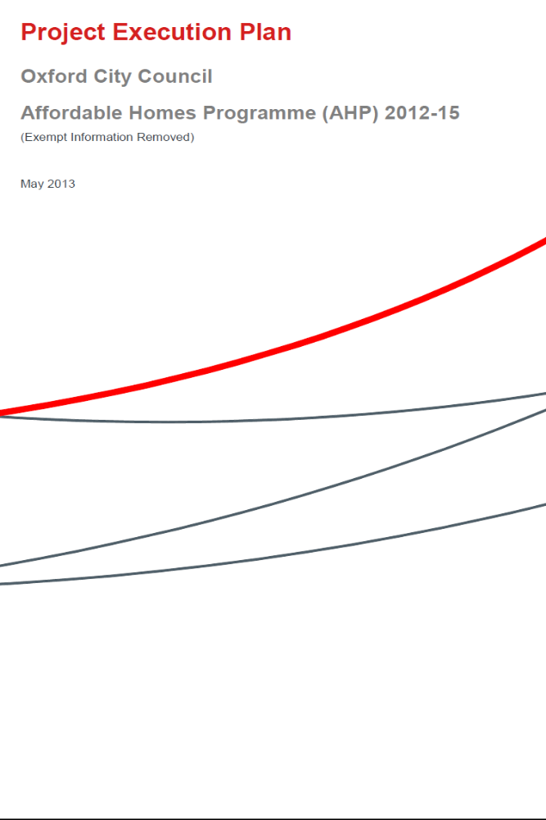

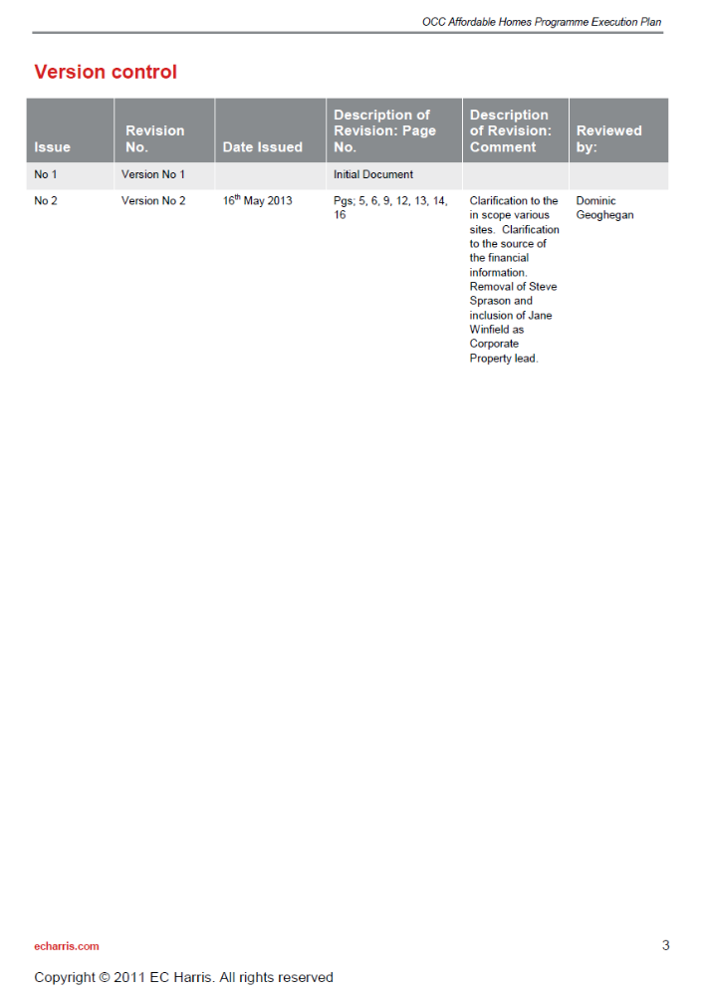
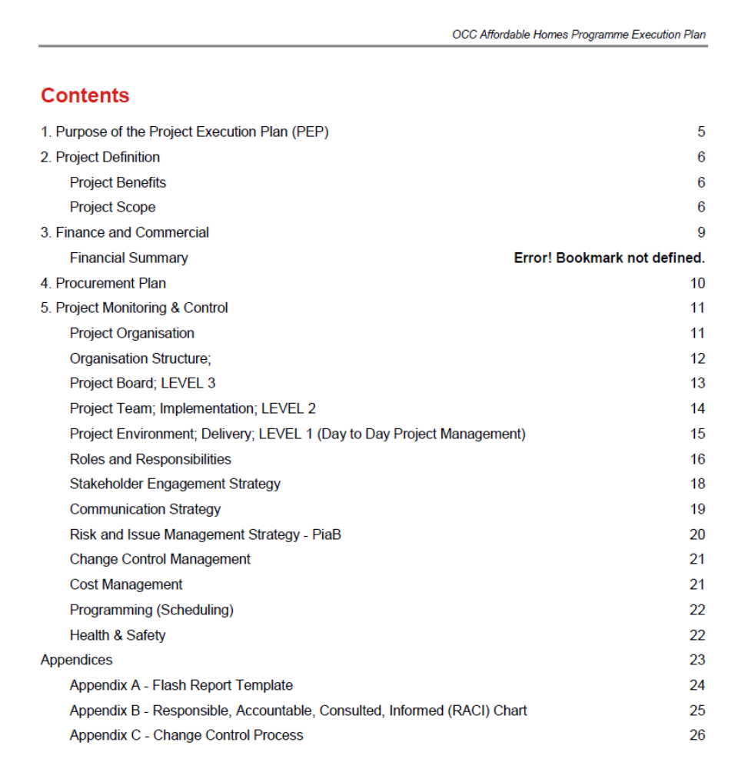
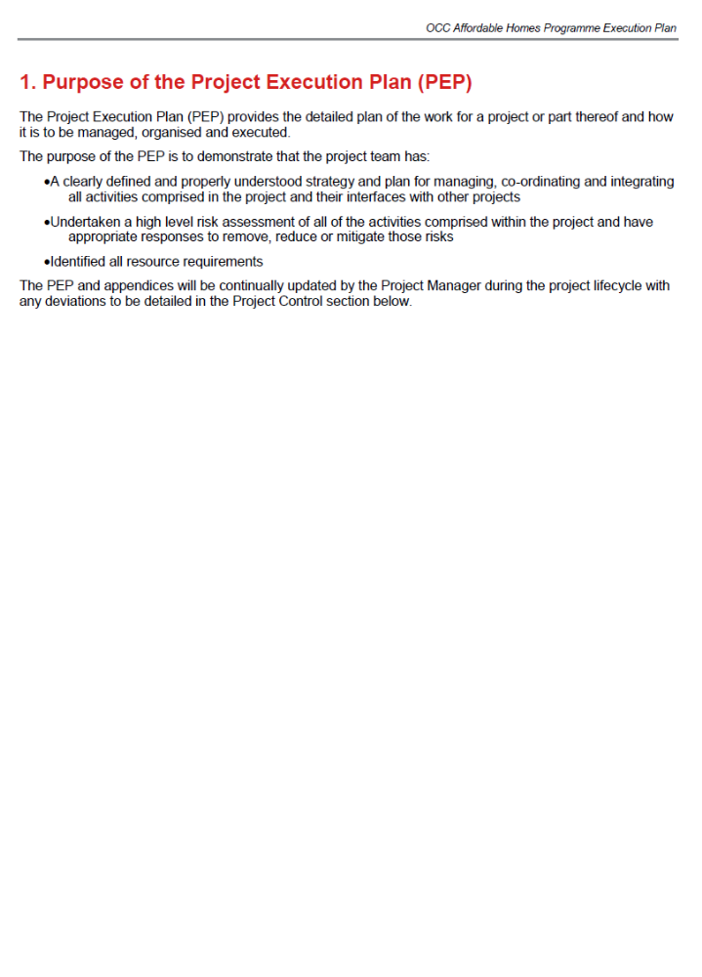
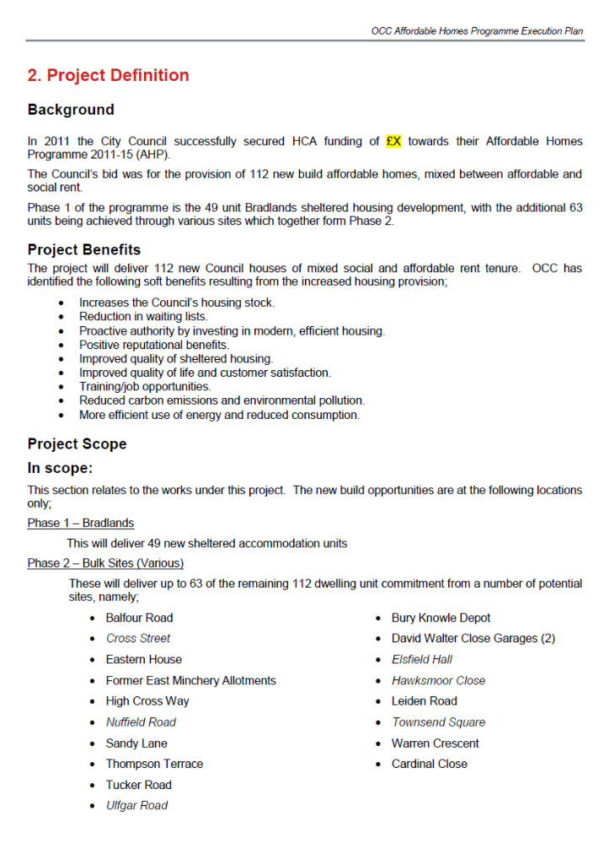
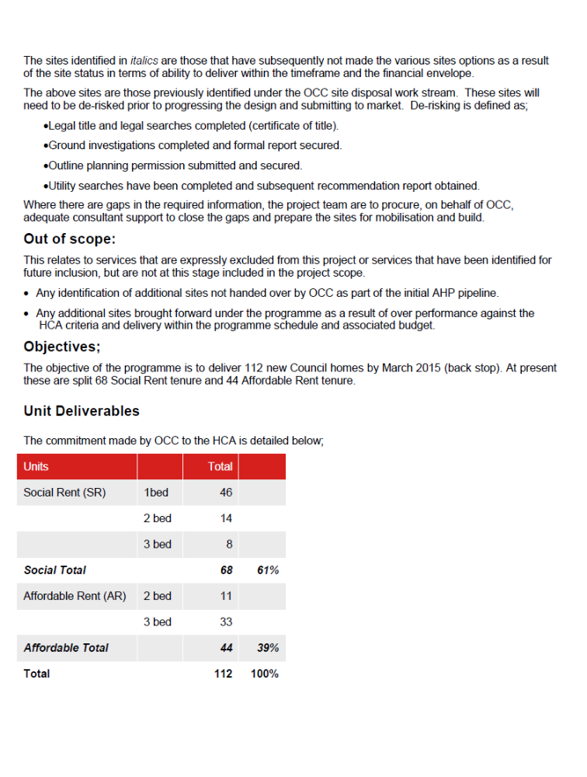
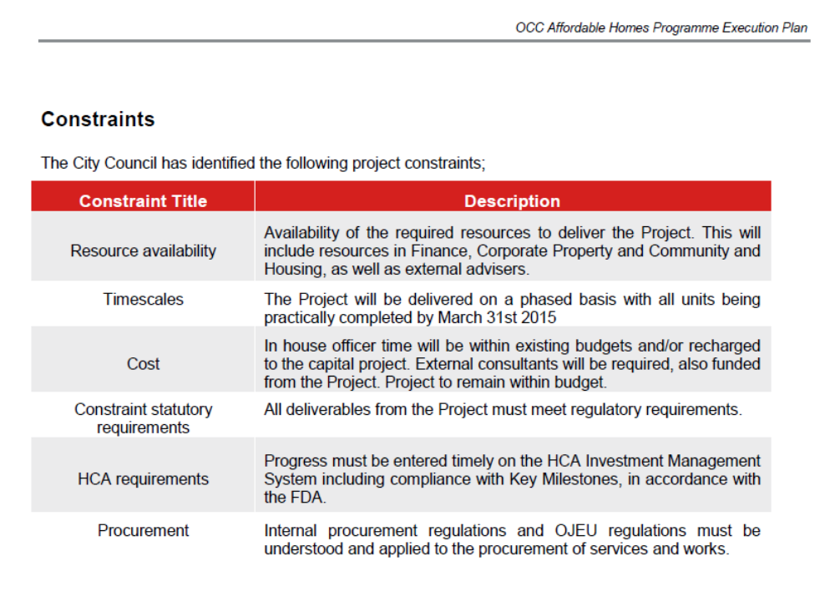
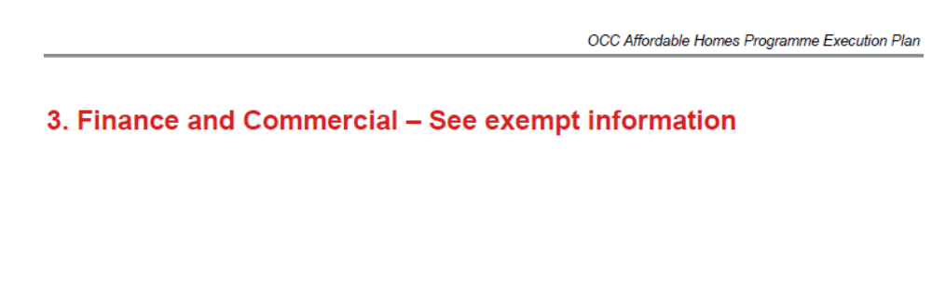
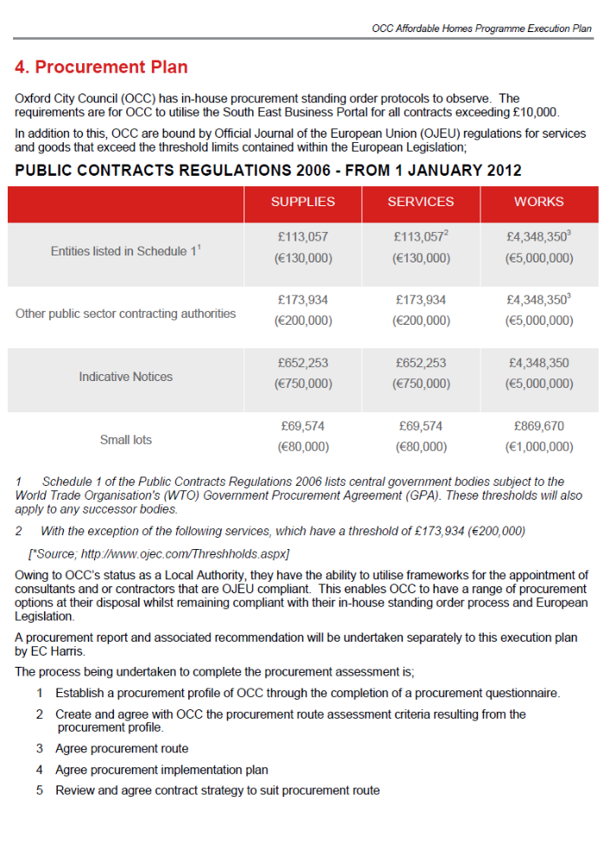
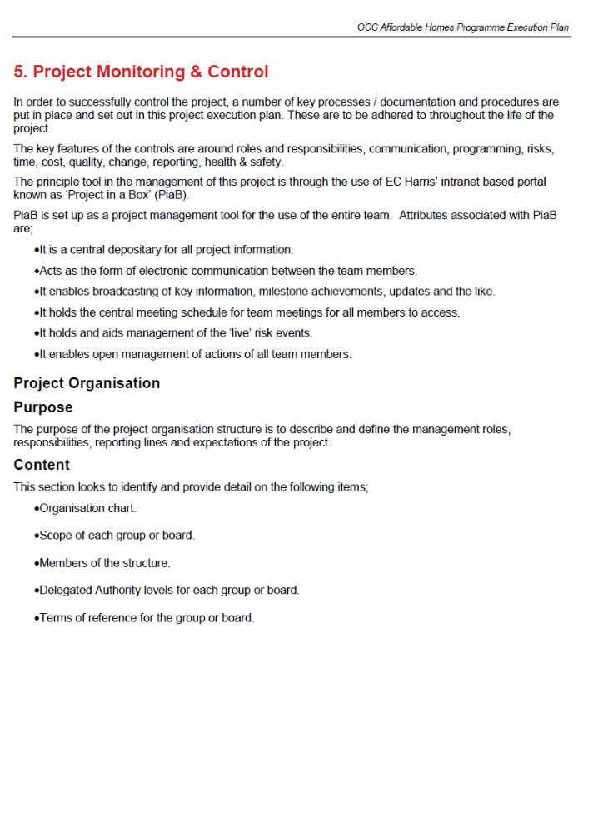
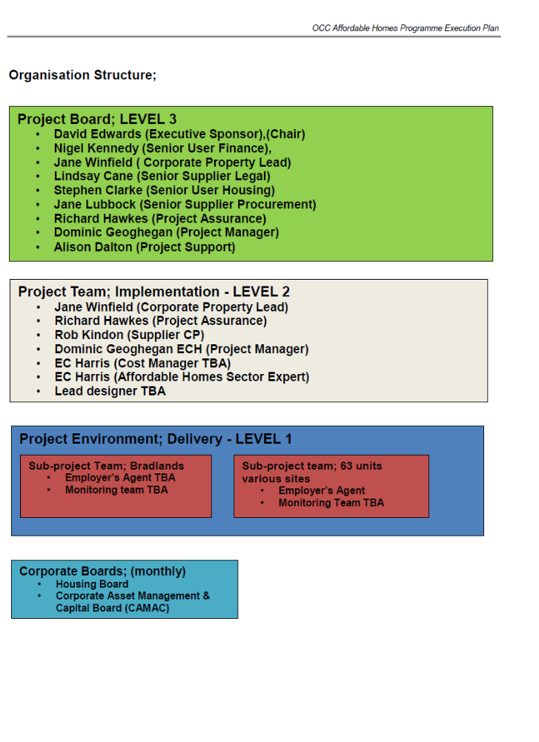

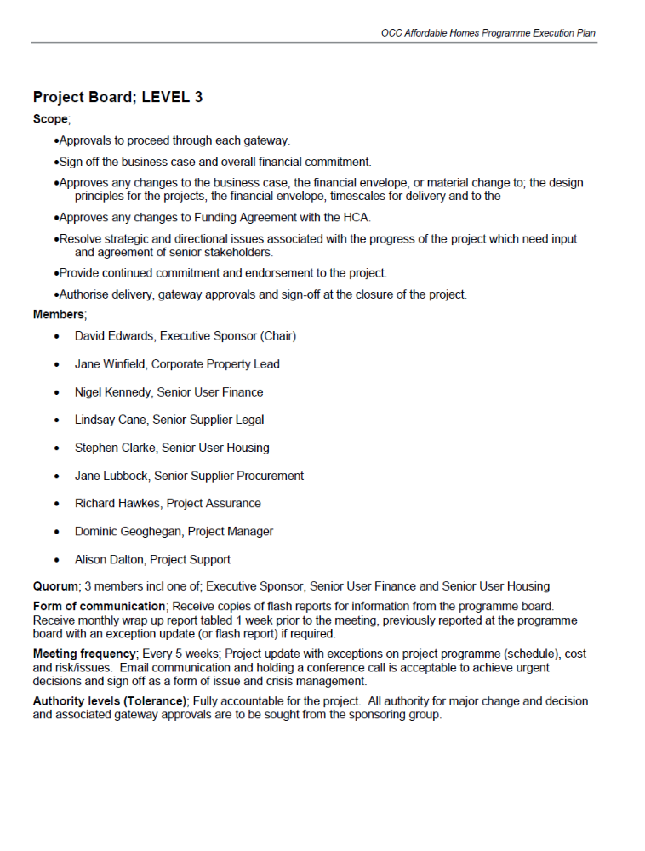
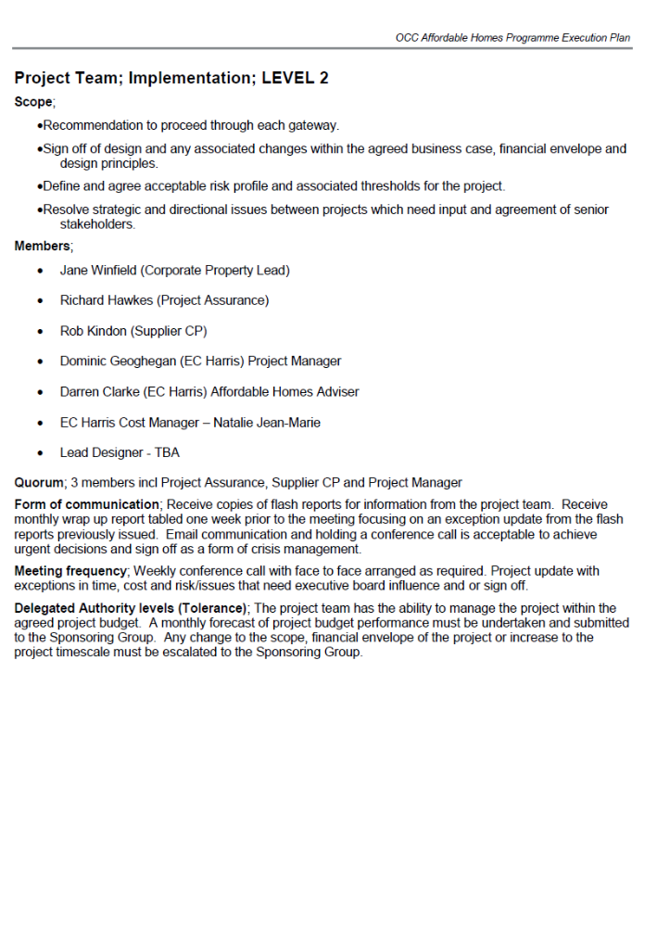
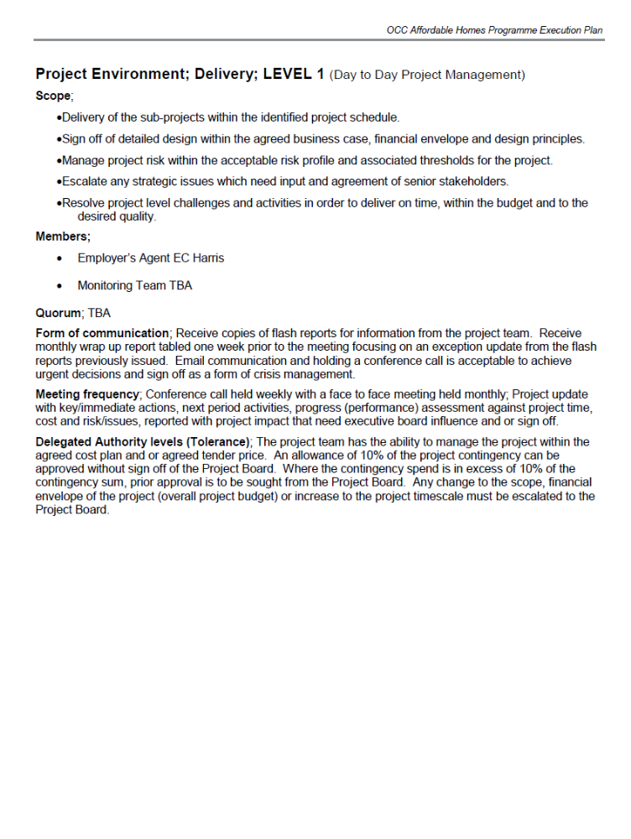
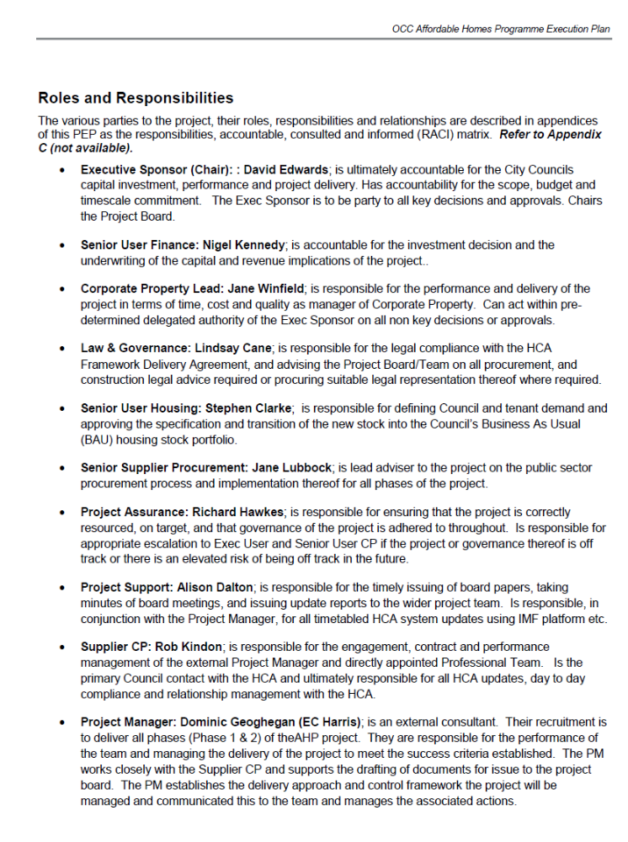
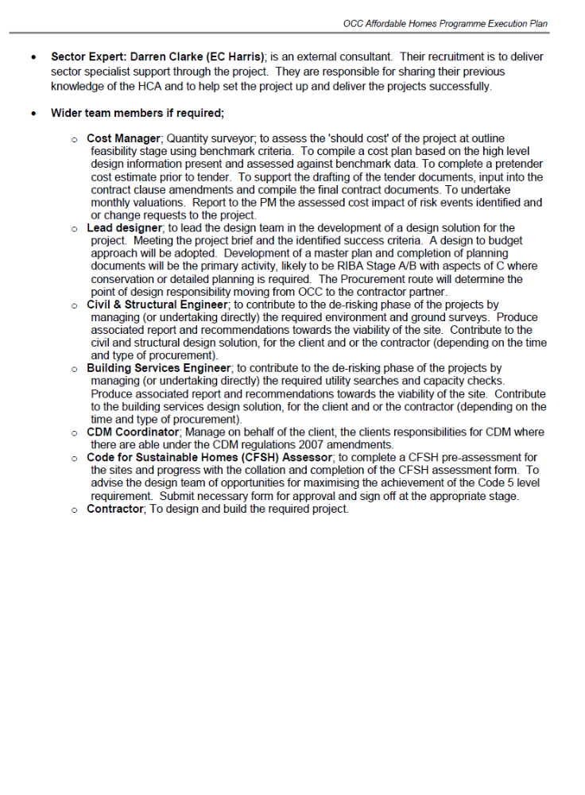
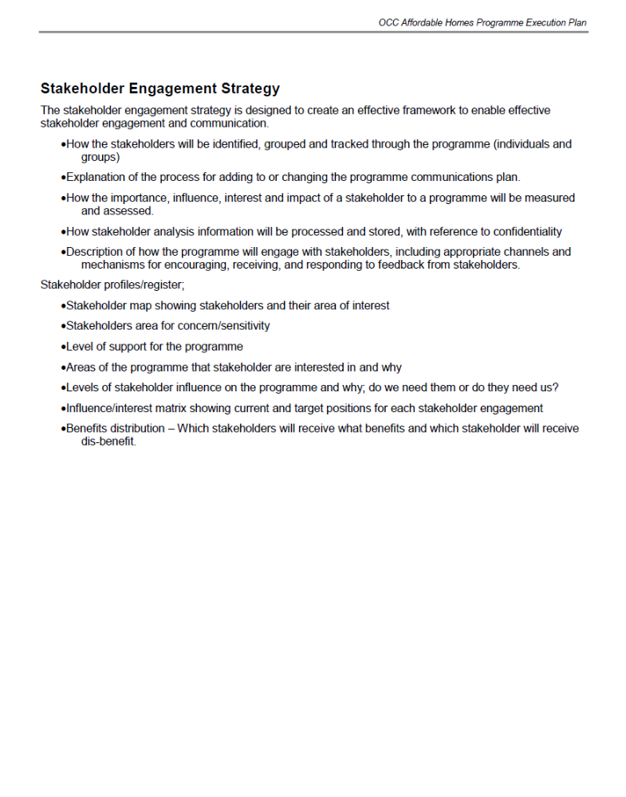
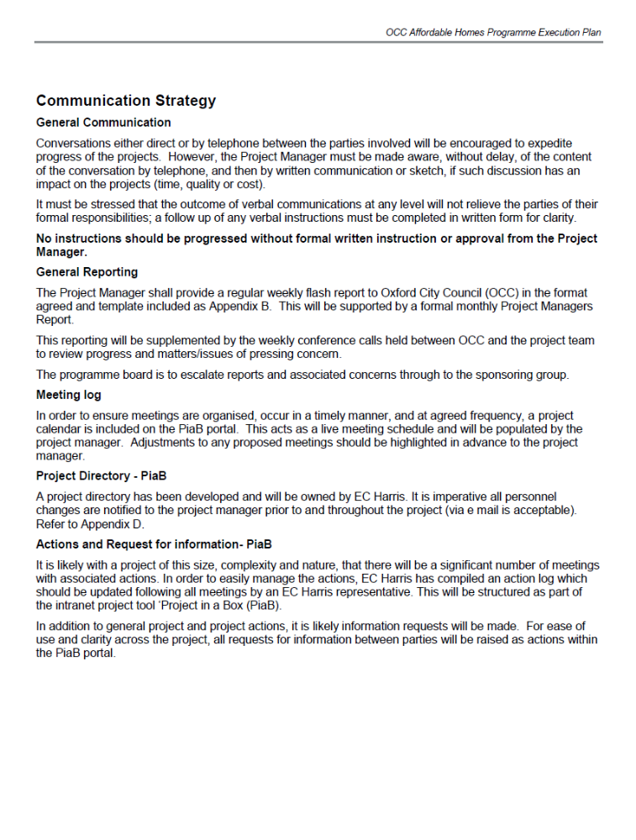
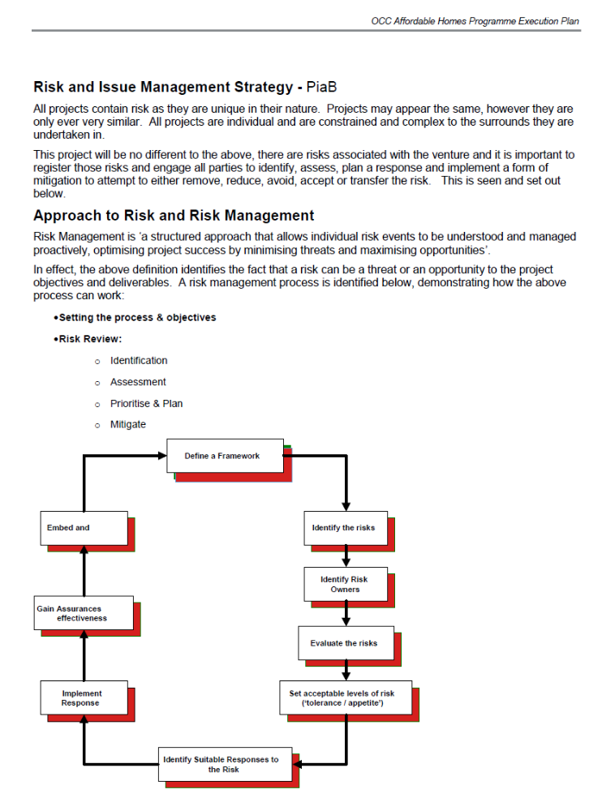
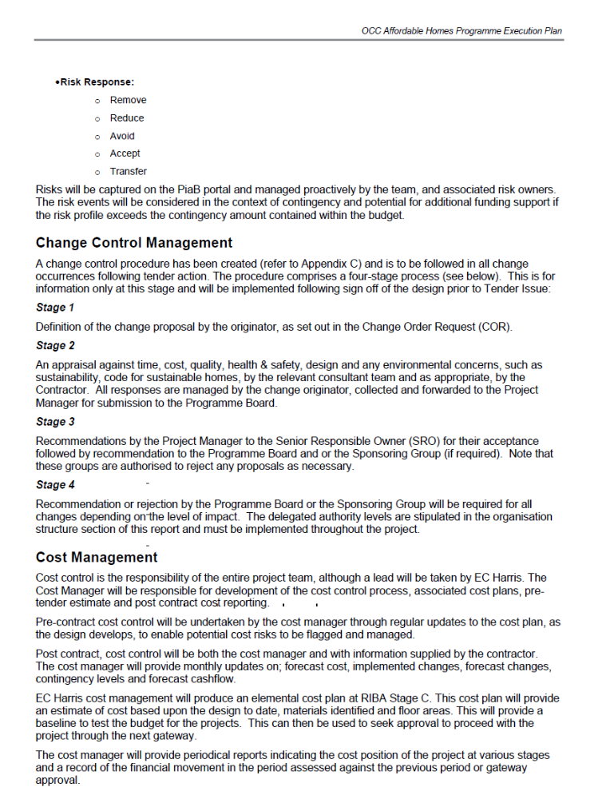
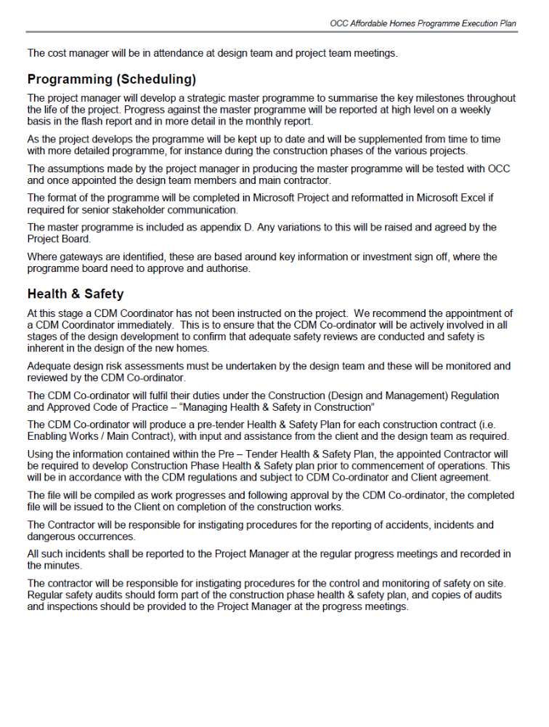

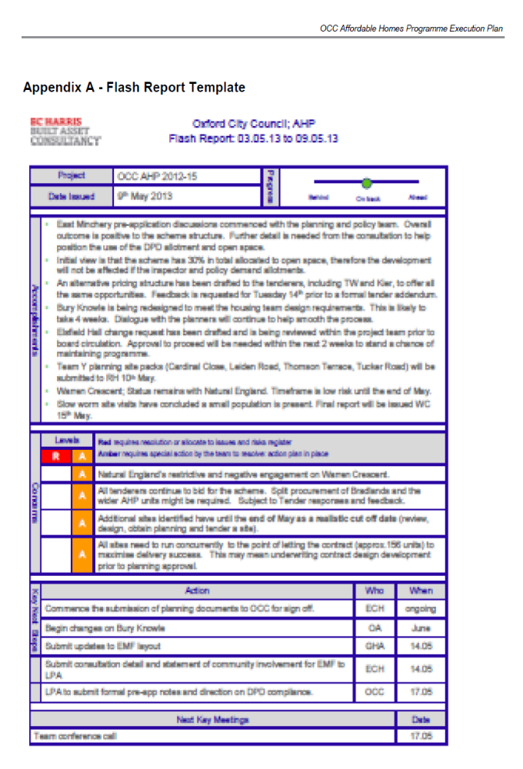

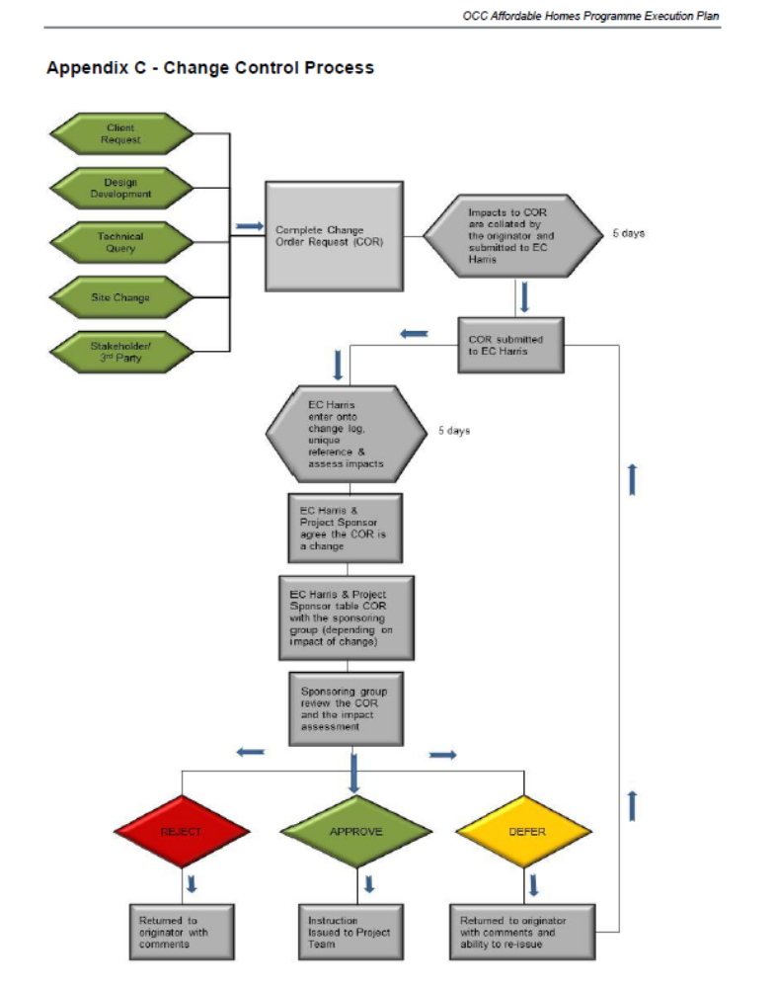
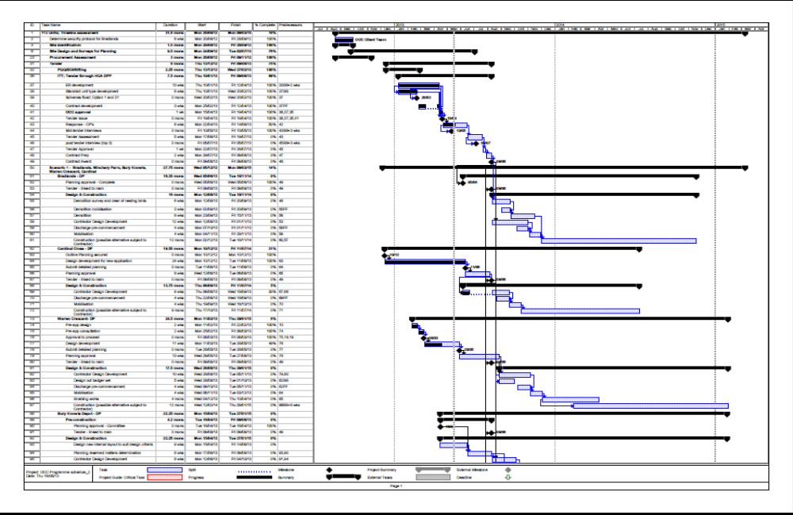
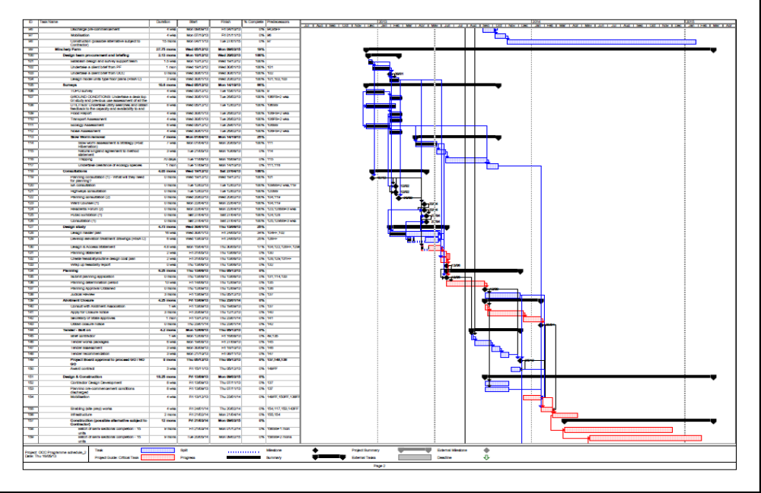
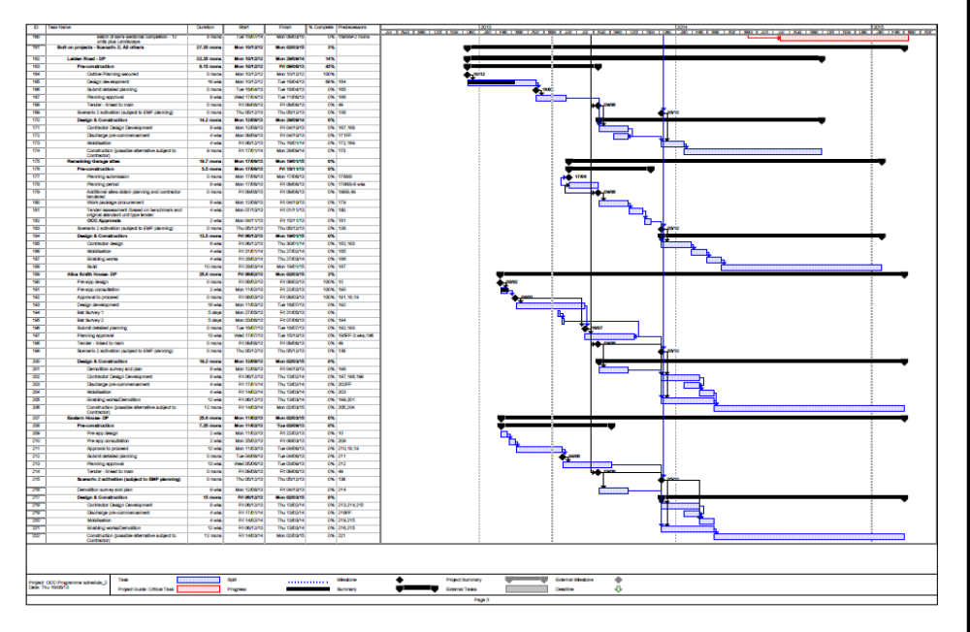

Appendix 2



